W4 PRACTICE
MANIPULATE BASIC WIDGETS

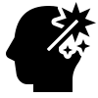 Learning objectives
- Start from an empty Flutter project
- Hot Reload
- Use Flutter doctor, update, create, run
- Use Flutter Documentation

- Manipulate Scaffold, Text, TextStyle, Radius
- Manipulate Colors palettes
- Manipulate Container, BoxDecoration, Center, EdgeInsets, Column

 No AI tools allowed to solve this practice

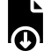How to submit?
- Push your final code on your GitHub repository
- Then attach the GitHub path to the MS Team assignment and turn it in

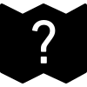 Are you lost?
Read the following documentation to be ready for this practice:

https://api.flutter.dev/flutter/material/Scaffold-class.html
https://docs.flutter.dev/ui/widgets/text
https://api.flutter.dev/flutter/widgets/Center-class.html
https://api.flutter.dev/flutter/painting/EdgeInsets-class.html
https://api.flutter.dev/flutter/widgets/Column-class.html
https://api.flutter.dev/flutter/widgets/Container-class.html
https://api.flutter.dev/flutter/painting/BoxDecoration-class.html

EX 1 – Scaffold, Text
In this exercise, you will be working with the following widgets

- Scaffold: Provides a basic structure for UI, like app bar, drawer, etc.
- Center: Aligns a child widget to the center
- Text: Displays text.

And the following classes
- TextStyle: Styles text appearance.

You need to produce the following mockup and widget structure:
 You are free to customize it!

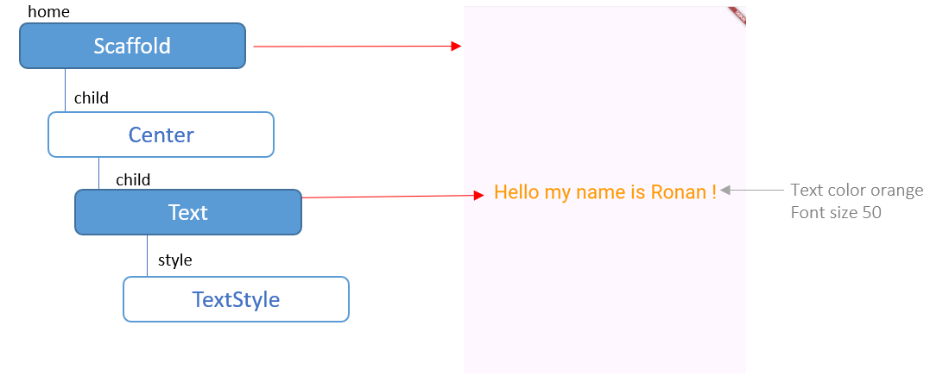

To start
Open W3-S2/EX-1/main.dart

void main() {
runApp(
const MaterialApp( ),
);
}

EX 2 – Container, Insets, BoxDecoration
In this exercise, you will be working with the following widgets
- Container: A customizable box for layout and styling.
- Text: Displays text.
- Center: Aligns a child widget to the center

And the following classes
- EdgeInsets: Sets padding or margin.
- BoxDecoration: Styles a container's background, border, etc.
- BorderRadius: Rounds container corners.
- TextStyle: Styles text appearance.

You need to produce the following mockup and widget structure:
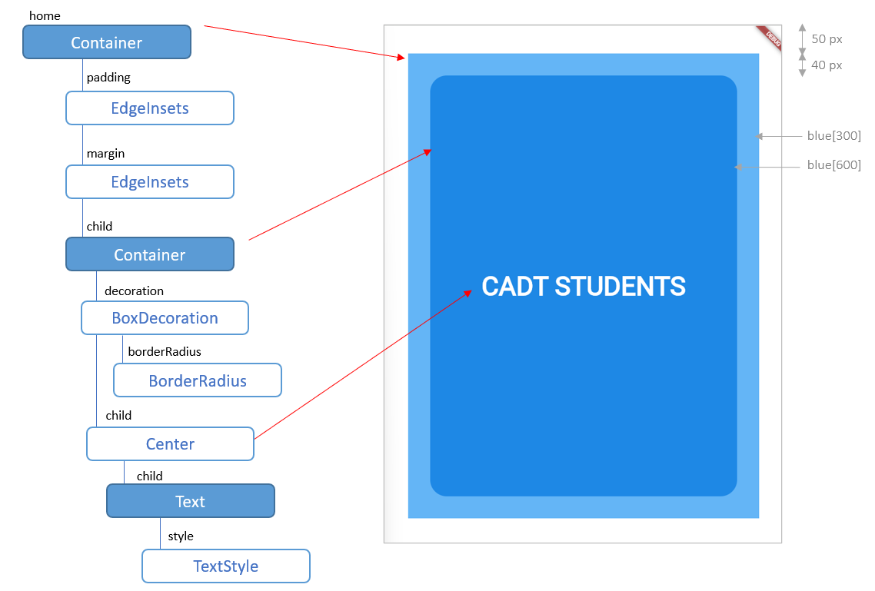

We recommend you to follow the bellow steps to be able to understand each widget in details.
However, you are free to choose your favorite workflow!

To start
Open W3-S2/EX-2/main.dart

void main() {
runApp(MaterialApp(
home: Container( ),
));
}

STEP 1 | 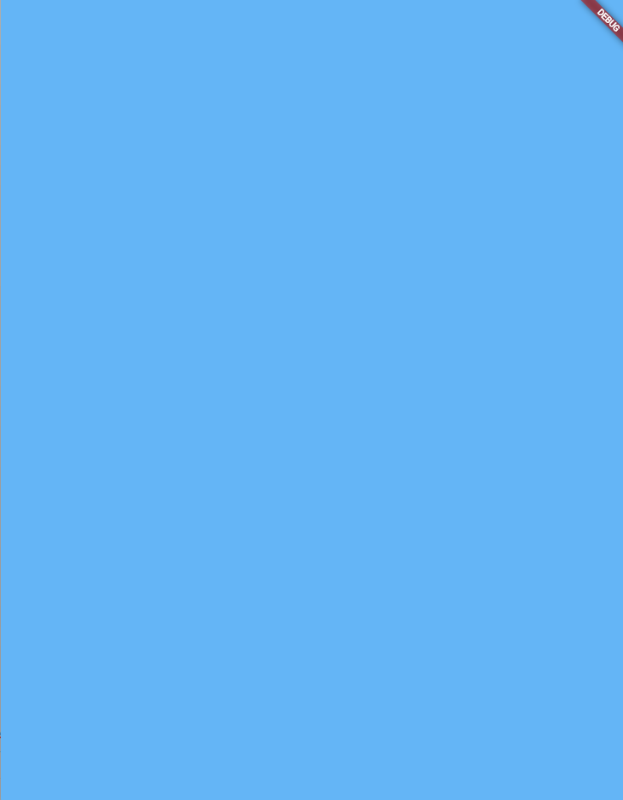 | Just a blue container for the home…  MaterialApp  home: Container
STEP 2 | 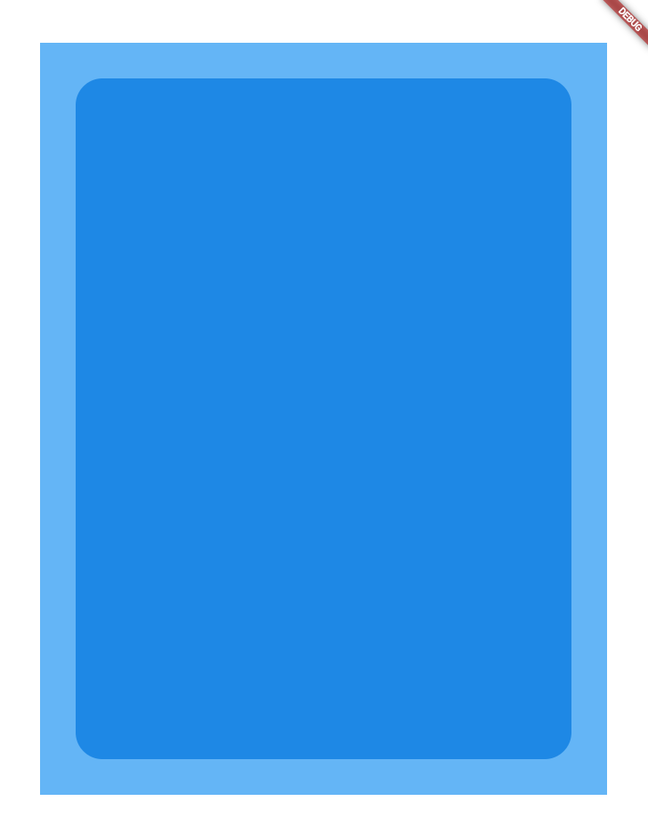 | Add an inner container and some padding margins and box decoration  MaterialApp  home: Container  margin: EdgeInsets  padding: EdgeInsets  child: Container  decoration: BoxDecoration
STEP 3 | 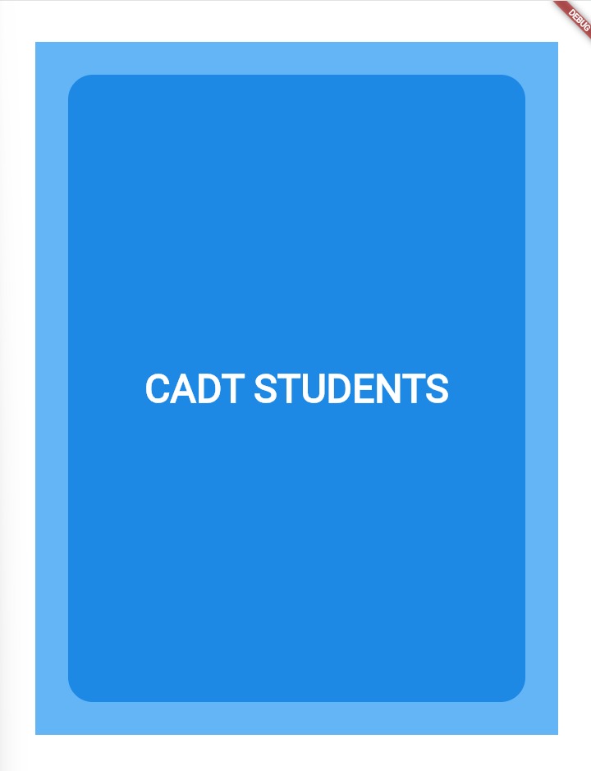 | Add the Text, centered, and style it.  MaterialApp  home: Container  margin: EdgeInsets  padding: EdgeInsets  child: Container  decoration: BoxDecoration  child: Center  child: Text  style TextStyle

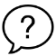 In this exercise, we haven’t used the Scaffold widget: Why? What is the purpose of this widget?

EX 3 – Column Gradient
In this exercise, you will be working with the following widgets

- Container: A customizable box for layout and styling.
- Column Arranges widgets vertically in a column.

And he following classes
- EdgeInsets: Sets padding or margin.
- BoxDecoration: Styles a container's background, border, etc.

You need to produce the following mockup and widget structure:
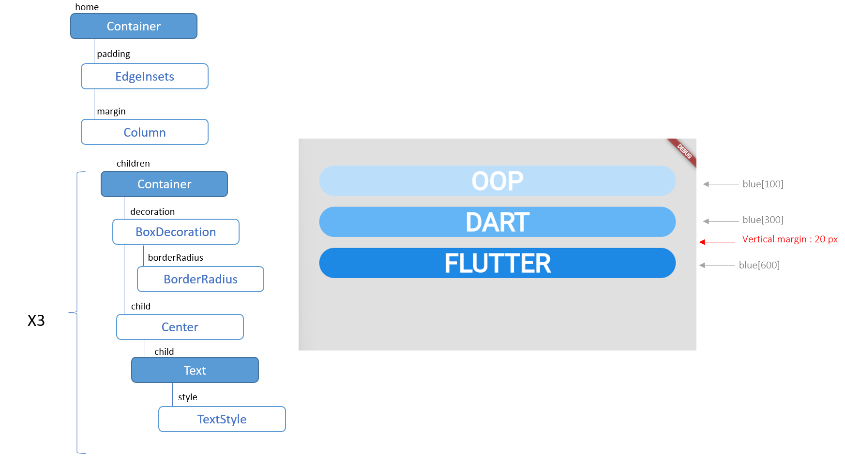

BONUS
In the last item, add a linear gradient as specified bellow

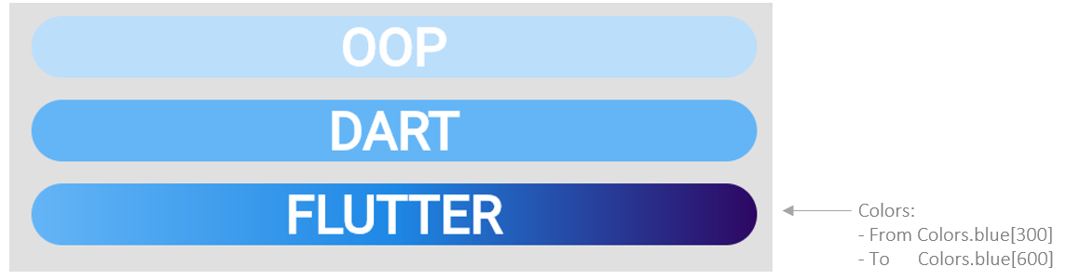

EX 4 – From mockup to code (PREPARE FOR TEST)

Build the bellow UI with the bellow screen:

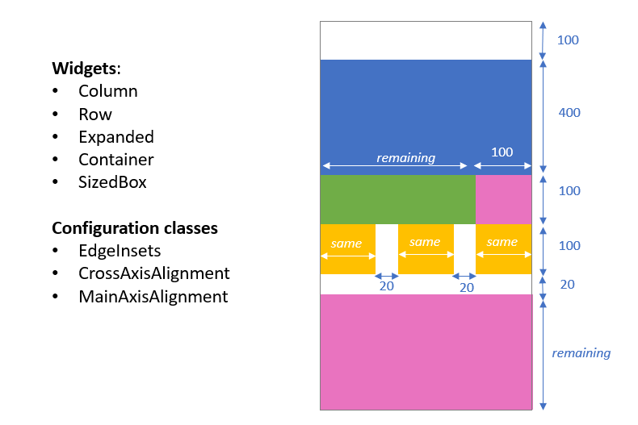

EX 5 – Your welcome page (PREPARE FOR TEST)
Your goal is to combine all the widgets you have learned and create a welcome page of your choice,

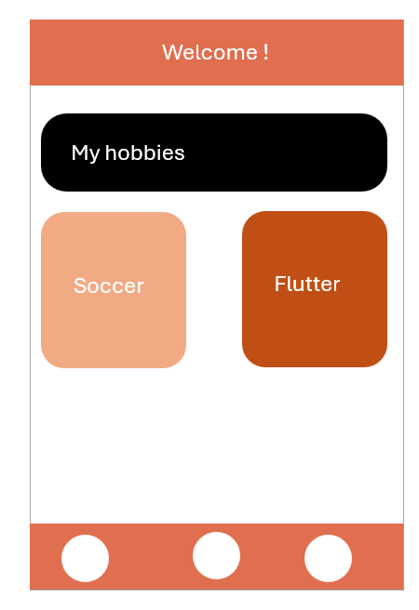

In this exercise, you can use the following widgets

1. Basic Structure
- Scaffold: Provides a basic structure for a mobile screen

2. Layout and Alignment
- Row: Arranges widgets horizontally
- Column: Arranges widgets vertically
- Center: Aligns a child widget to the center
- Expanded: Makes a child of a Row, Column, or Flex fill the available space
- SingleChildScrollView: Makes a single child scrollable

3. Spacing and Styling
- Container: A customizable box for layout and styling
- SizedBox: Defines a fixed width or height or adds space between widgets
- Padding: Adds empty space around a widget's child

4. Content
- Text: Displays text.

And the following classes
• TextStyle: Styles text appearance.
• BoxDecoration Styles a container's background, border, etc.
• EdgeInsets : Sets padding or margin.

💡 You want to draw a circle? You can customize the contain box decoration with a circle shape:
Container(
width: 100.0,
height: 100.0,
decoration: BoxDecoration(
shape: BoxShape.circle,
),
)

